
School of Computer Science and Engineering
Fall Semester 2024-25
CAT I
SLOT: B1 Slot
Programme Name & Branch: B. Tech CSE
Course Name & Code: Operating Systems & BCSE303L
Class Number (s):
Faculty Name (s):
Exam Duration: 90 Min. Maximum Marks: 50

Q. No. | Question | Max Marks | CO | BL
1. | A multiprocessor system contains more than one CPU (also known as processor) and they work in parallel. This is called Simultaneous Multiprocessing (SMP). Multiprocessor systems have a special type of motherboard which has several CPU sockets.  A multicore system contains more than one execution core on one CPU. The exact meaning of multicore depends on the architecture, but essentially a certain subset of the CPU's components is replicated, so that several cores can work in parallel on isolated CPU operations. This is called Chip-level Multiprocessing (CMP). A multicore chip can have a dedicated execution unit and L1 cache for a core and a shared L2 cache for the entire CPU.  Multiprocessor means having several CPUs whereas multicore means having several cores.  The operating system controls all a computer system's hardware resources, including processor, memory, storage space, network controller, peripherals, and user input/output. As such, it controls many resources that need protection. Some of the tools an OS often utilizes include user identity management, anti-malware software, network firewalls, and encryption.  The operating system operates at many levels of security. It controls access to hard drives, network controllers, and user interfaces. Therefore, it participates in security at the data, user, and network levels. It also plays a role in mitigating damage at the physical security level through the use of backup and restore operations. | 5+5 | CO1 | BL2
2. | Definition - A system call is a request from computer software to an operating system's kernel. (1 mark)  Need - System calls allow user-level processes to request services of the operating system  Simplicity – No need to write complex code (1 mark)  Parameter passing methods (3 marks)  1) Parameters should be pushed on or popped off the stack by the operating system.  2) Parameters can be passed in registers.  3) When there are more parameters than registers, it should be stored in a block, and the block address should be passed as a parameter to a register.  Instruction Mode (5 marks)  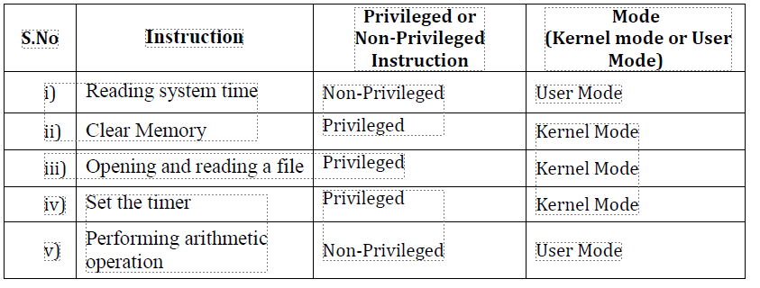 | 5+5 | CO1 | BL4
3. | 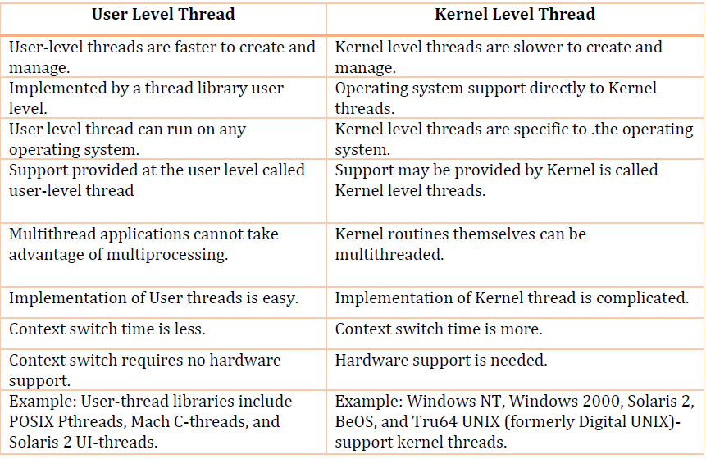 | 10 | CO1 | BL5
4. | 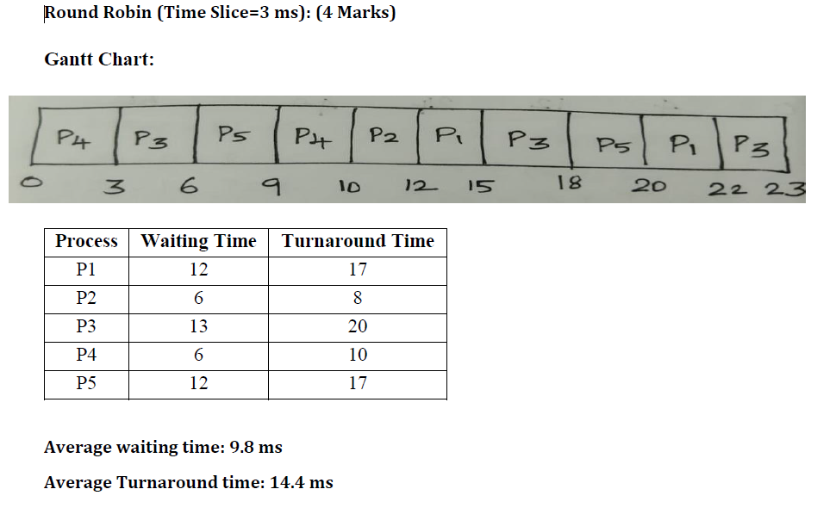  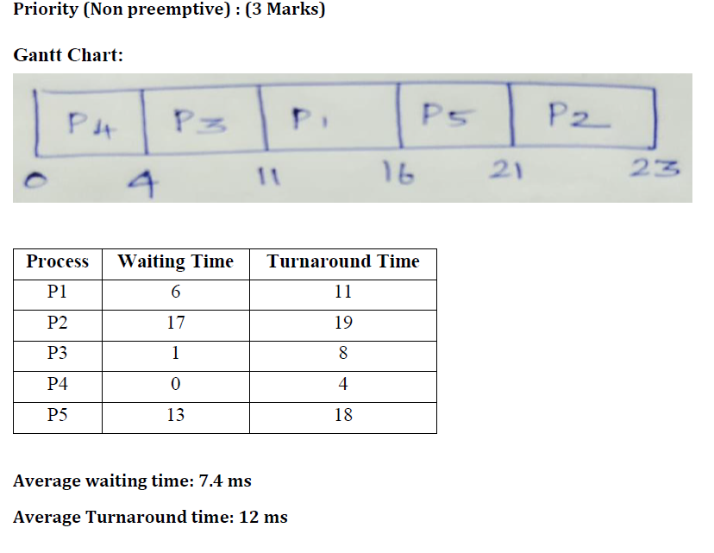 | 10 | CO2 | BL3
5. | 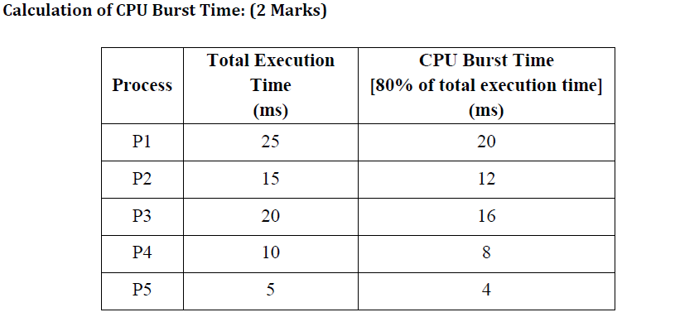  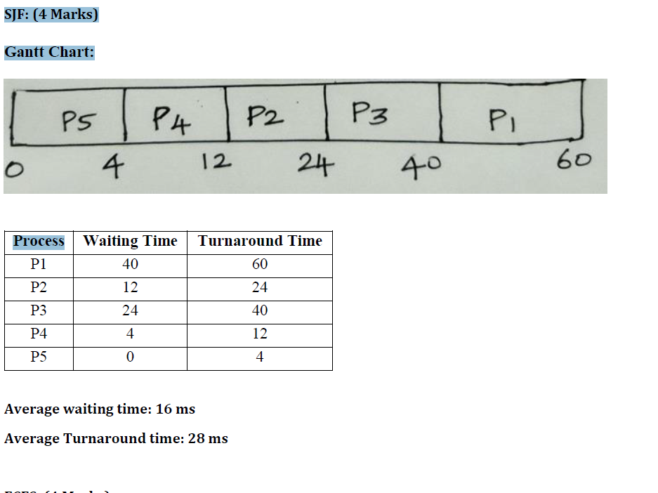  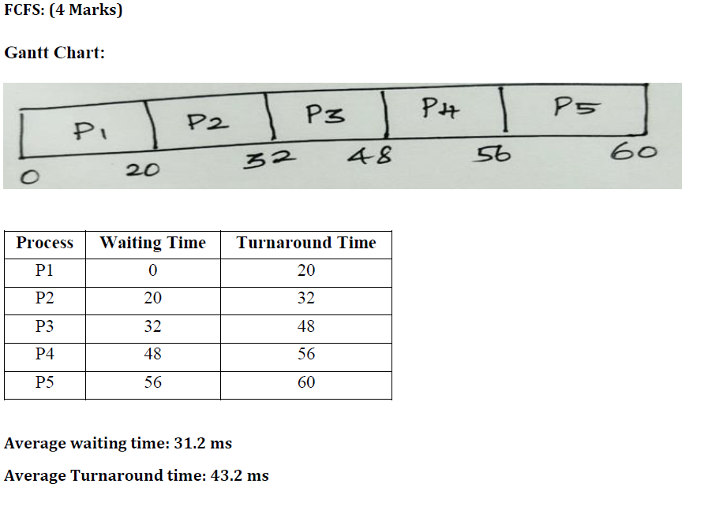 | 10 | CO2 | BL3

